Matrices and determinants are very nice ways to vepresent bunch of number. matrices as well as determinants dlong with some very nice properties that each of then have, prove to be very useful in solving equations, finding area of polygons etc. Matrices a also find use in Linear Algebra which is beyond the scope of JEE syllabus.
So, Let us study these in details.
Matrices And Determinants
MATRICES
A rectangular away of elements or symbols.along sows and wlumns in colled a matricx .
Equal MAtrices :- Two matrices are eqnal if they have the same order and each element of ove is equal to the corresponding of the other.
Classification (Secondaty Information):-
Row Matrix
A mstrix lhaving a single row .
Column Matrix
A matrix with a single column .
Square Matrix
An m X n matrix is said to be a square matrix if m = n i.e. no. of rows = no. o of columns.
eg: A - 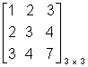
Trace of a Matrix
The sum of the elements of O square matrix A lying along the principal diagonal .
Properties of trace of a matrix(Secondary Information) :-
(i) tr (A) = tr (A)
(ii) tr (A + B) = tr (A) + tr (B)
(iii) tr (A B) = tr (B A)
Diagonal Matrix (Secondary Information) :-
A square matrix with all the elemente O except the diagonal elements.
Scalar Matrix:- A diagonal matrix whose all the leading elements are equal.
Unit or Identify Matrix:-
A diagonal matrix of order n which has only unity for all its diagonal elements. is called unit or Identify matrix of order n and is denoted by In.
Triangnlar Matrix (Secondary Information):
A square matrix in which all the elements below the diagonal are zero is called upper triangnlar and square matrix in which all the elements above diagonal are zero is called lower triangnlar matrix
Null Matrix :-
MAtrix with all elements O.
Transpose of a Matrix:- The matrix obtaired from a given matrix A, by inter changing rows and columns is called transpose of A and is denoted by a^{T} . or A ¹.
Properties of Transpose (Secondary In formation):-
(i) (A^{T})^{T} = A
(ii) (A + B)^{T} = A^{T} + B^{T}
(iii) (A)^{T} = . A^{T}
(iv) (A B)^{T} = B^{T} A^{T}.
Conjugate of a Matrix:- A matrix obtained from any given matrix A coutaining complex number as its elements, or replaing its elements by the corresponding conjugate complex no is called conjugate of A and is denoted by .
Properties of conjugate (Secondary Information:-
(i) = A
(ii)
(iii)
(iv)
Transpose Conjugate of a Matrix:-
The transpose of conjugate of a matrix denoted by .
Properties of Transpose of conjugate:-
(Secondary Information):-
(i)
(ii)
(iii)
(iv)
ALGEBRA OF MATRICES:-
Addition and Subtraction:- Any two matrices can be added lif they are of same order and the (or Subtrected)
resulting matrix is of same order, corresponding elements are added or subtracted .
Scalar Multiplication:-
The matrix obtained by multiplleying every element of by a scalar is called the scalar multiple of A by and is denoted by A .
Multipliecation of Matrices:-
Two matrices can be multiplied lonly when the no of columns in the first is equal to the no . of rows inm the second. Such matrices are called conformable for multiplication.
If A B = c
A - [a_{ij}] _{mXn} B - [b_{ke}] _{nXp}
C _{ij}² 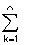a _{ik} b _{kj}
Special Matrices (Secondary Information:-
Symmetric and Skew Symmetric Matrices:-
A square matriex is A is said to be symmetric if
A = A^{T}.
and skew symmetric if A = - A^{T}.
Unitary Matrix
A matrix is unitary if A = 1
Hermition and skew - Harmition Matrix :-
A square matrix is said to mermition if A = .
and skew Hermition if = - A .
Singular Matrix :- Ahy square matrix A is singular if | A | = O .
Orthogonal Matrix :- Any squrae matrix A of order n is said to be orthogonal if A A^{T} = A^{T} A = I_{n}.
Idempotent Matrix :- A square matrix is called idmpotent provided it satisfies the selation A² = A .
In volutary Matrix :-
A matrix such A ² = I .
Nilpotent Matrix
A square matrix such that A ^{m} = O where m is Q posetive integer .
Adjoint of a Square Matrix
Let A be a square matrix of order n and let C_{ij} ;be cofactor of a_{ij} in A. Then the transpose of the matrix of cofacturs of elements of A is called the adjoint of A and is denoted by adj A .
We have
A (adj A) = | A | I_{n} = (adj A) A
Onverse of a Matrix
A no n - singular square matrix of ordere n is invertible if there exists a square matrix B of the same order such that AB = I_{n} = BA .
A⁻¹ = B
A⁻¹ = adj A .
properties of inverse of a matrix :-
(Secondary Information).
(i) (A B)⁻¹ = B⁻¹ A ⁻¹
(ii)(ABC ........ ) ⁻¹ = ........C⁻¹ B⁻¹ A⁻¹
(iii) (A^{T}) ⁻¹ = (A⁻¹ )^{T}
(iv) A is a no n - singular matrix of order n . There |adj A| = |A| ^{1-n}
(v) (A B) = adj B . adj A .
(vi) A is are invetible square matrix . There
adj (A^{T}) = (adj⁻A)^{T}
(vii) If A is a no n - singular square matrix, there
adj(adj⁻A) = |A|^{n-2} A .
System of Simultaulons Linear Equations :-
a₁₁ x₁ + a₁₂ x₂ + ....... + a_{1n} x_{n} = b₁
a₂₁ x₁ + a₂₂ x₂ + ....... + a_{2n} x_{n} = b₂
a_{n1} x₁ + a_{n2} x₂ + ....... + a_{nn}x_{n} = b_{n}
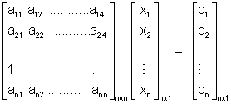
AX = B
X = A⁻¹ B
(i) If A is non singular, the system of equation AX = B has a uonique so1⁴ given by X = A ⁻¹ B .
(ii) If A is singular and (adj A) B = O, there system of equation given by AX = B is cousistent with. Infinefely many solutions.
(iii) If A is a singular matrix,and (adj A) . B O, then the system of equation given by AX = B is inconsistent
DUMB QUESTION
Q1. If co-ordinates (x, y)one rotated by are augleabout the arigin the new coordinetes are represnted by matrix . How ?
Sol^{n} :- 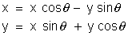
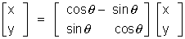
Illustration :-
Q1. A = 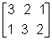and B 2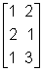 show that A B B A .
Sol^{n} :- A . B = = 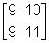
B . A = = 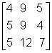
Q 2. Show taht A = 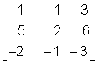is ...of index 3.
Solution :- A² = 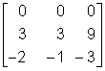
A³ = A² - A = 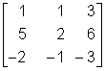
= 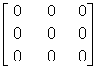
A³ = 0 i.e. A^{k} = 0
DETERMINAATS :-
The experssion 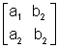is colled a determinant.
Calculation of determinants
= a₁ b₂ - a₂ b₁
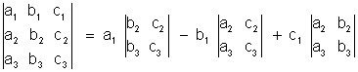
= a₁ (b₂ c₃ - b₂ b₃) - b₁ (a₂ c₃ - c₂ a₃) + c₁ (a₂ b₃ - b₂ c₃)
Properties of determinants (Secondary Information) :-
1. If rows be changed into columns and columns into the rows, the determinant remain unaltered .
2. If any two rows or columns of a determinant are interchanged the resulting determinant is the negative of the original determinant .
3. If two rows (or ltwo columns) in a determinant have corresponding entries that are equal, the value of the determinant K, then determinant is multiplied by K .
4. If each of the entries in a row (or column) of a determinant is multiplied by K, then determinant is multiplied by K .
5. If each entry in a row (or column) of a determinant is written as the sum of two or more trems than the determinant can be written as the sum of two more determinants .
6. If to each element of a line (row or column) of a determinant be adeled the equimultiples of the corresponding elements of one or more parallel lines, the determinant remains unaltered .
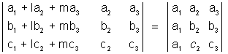
7. If each entry in any cow (or column) of determinant is zero, then the volue of detrminant equal to zero .
8. If determinant varishes for X = a, then (X - a) is a factor of D .
Product of two Determinants :-
Differentiation of a determinant (Sexondary Information) :-
(X) = 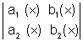then (X) = 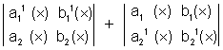
Similarly if
(X) =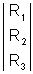, then¹ (X) = 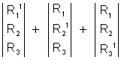
Summation of Determinants :-
(Secondary Information)
Let r = 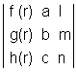
Then 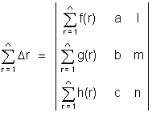
Integration of Determinants (Secondary Information ) :-
(X) = 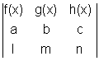
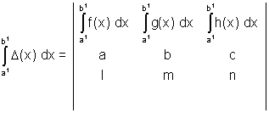
Special Determinants (Secondary Information) :-
1. Symmetric Determinant :-
The elements situted at equal distance from the diagonal are equal both in magnitude and sign.
eg. 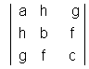
Skew symmetric determinant :- Determinant of skew symmetric matrix .
3. Circulant :- The elements of the rows (or columns) are in cyclic arangements .
eg . 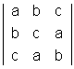
Solution of system of Linear Equations :-
a₁X + b₁ y + c₁ z = d₁
a₂X + b₂ y + c₂ z = d₂
a₃X + b₃ y + c₃ z = d₃.
D = 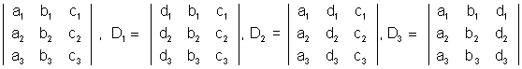
X = D1/D Y = D2/D Z = D3/D
The following cases arise
(1) D O, the system has one unique solution .
D = O, D₁, D₂, D₃ O, then system is incories tant .
(2) D₁ = O, and D₁ = D₂ = D₃ = O, then the system has infinite solutions .
Illustrations
Q 1. Without expanding, show taht 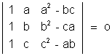
Solution :- L H S = 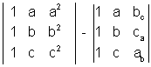= 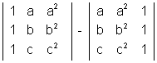[ R₁ a R₁, R₂ b R₂, R₃ c R₃ and abc taken common]
= 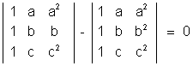
Q 2. Prove that
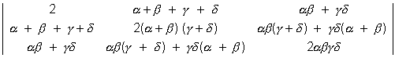=
Solution : L H S :-
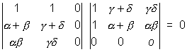
ASSIGNMENTS
EASY
E 1. If a₁b₁ c and d are real constants and A
= 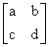,prove that A² - (a + b)A + (ab - bc) I = 0
Sol :- A ² = 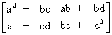
A² = A² - (a + b) A + (ab + bc)I
= 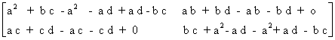
E 1 A = 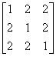show taht A ² 4 A - 5 I = o
SOl :- A ² = 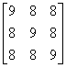
A² - 4 A - 5 I = 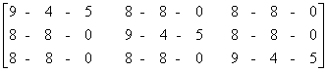
E 3. Solve syste the equation .
X + 3y - 2z = 0., 2x - x - 4z = 0, x - 11y + 14z = 0
Sol :- 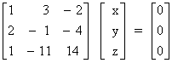=> A X = B .
|A| = 0
Solving the terme of z .
x = 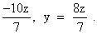.
=> x = - 10 k , y = 8 k , z = 7 K
E 4 . For what value of x, the matrix
A = 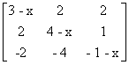is singular .
Solution :- | A | = 0
=> x [(3 - x) (1 + x - 4) - 0 + 2 (2 - 2) ] = 0
x (3 - x) (x - 3) = 0 img x = 0, 3
E 5 :- Evaluate 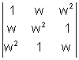
Sol :- Applying c¹ c₁ + c₂ c₃
=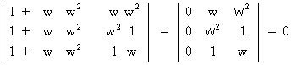
E 6 :- For what value of K do the following homogenous system of equations passes a row trivial solution .
x + ky + 3z = 0
3x + ky - 2z = 0
2x + 3y - 4z = 0
Sol :- D = 0
D = 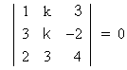
R₁ - 3R₁ and R₃ - 2R₁
=> 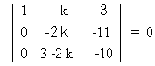
k = 33/2
E 7. Evoluate 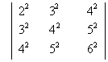
Sol :- R₂ - R₁, R₃ - R₂ then C₂ - C₁ and C₃ - C₂
D = 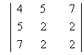
c₃ - c₂
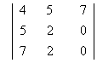= 2 [ 10 - 14 ] = - 8
E 8. If 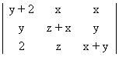= K X Y 2 , Find K .
Solution :- Putting x = 1, y = 1, z = 1 [As if in true for any volues of x₁ y₁ z₁
k = 4
MEDIUM
M 1. Determine and if 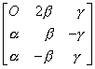is or thogonal
Sol^{n}:- AA¹ = 1
=>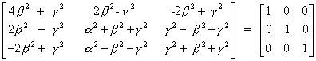
=> 4
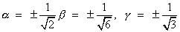

M 2. Using elementary row trans formations find the inverse of the matrix A = 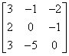
Sol^{n} :- A = I A
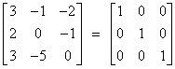A
. R₁ R₁ - R₂
. R₂ - 2R₁ and R₃ R₃ - 3R₁
. R₂ 1/2 R₂
. R₁ R₁ + R₁ and R₃R₃ + 2R₂
. R₃ 1/2 R₃ and .R₁ R₁ + 1/2 R₃ and R₂R₂ - 1/2 R₃
We get :-
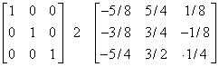A
A ⁻¹ = 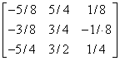
M 3 If a, b and c are P^{th}1 q^{th} and r^{th} terms of are
H.P., prove taht 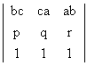= 0
Solution :- A : First term, D : Common difference
1/a = A +(p -1) D, 1/b = A +(q - 1) D, 1/c = A + (r - 1)D
abc 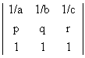
R₁R₁ - D R₂ - (A - D)r ,
= abc 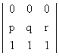= 0
M 4 . for what valume of m, does the system of equation 3x + my - mand 2x - 5y = 20 lhas a solution satisfying the condstion. x > 0, y > 0.
Solution = 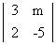= - (15 + 2_{m})
₁ = - 25m 2 = 60 - 2m
X = 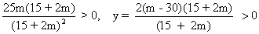
=> m > 30 or m < -15/2
HARD
H 1. Show that the produst of two triangular matrices is itself triangular.
Sol^{n}:- A = [Aij]_{nxn} and B = [bjk]_{nxn}
aij = 0 , i > j and bjk = 0 j > k
AB = [cik]_{nxn} then cik = aij bik
Suppose i > k
if j < i, then aij = 0 => aik = 0
if i < j, then j > k , because i > k , => bjk = 0
=> cik = 0
Hence c i k = 0 for i > k
Hence AB is also triangular .
H 2 . Without expanding at any stage show taht
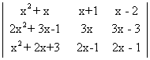= AX + B
Where A and B are determinants of order 3 not involving X:
Solution:- L.H.S. = 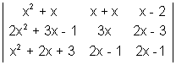
"R₁ + R₃ - R₂" and then "C₁ - C₃" and C₂ - C₃"
L.H.S. = 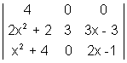
"R₂ - R₁ and R₃ - R₁"
L.H.S. = 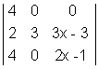
= 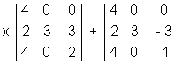
= Ax + B = R.H.S.

KEY TERMS
1. Matrix
2. Diagonal Matrix
3. Row Matrix
4. Column Matrix
5. Sclar Matrix
6. Unit or Identity Matrix
7. Triangular Matrix
8. Null Matrix
9. Tranpose Matrix
10. Conjnagte of a Matrix
11. Symmetri and Skew- Symmetric Matrices
12. Hermitian and Skew - Hermitian Matrices
13. Unit any Matrix
14 Singular Matrix
15. Orthogovel Matrix
16. Idem potent Matrix
17. Involutary Matrix
18. Nilpotent Matrix
19. Square Matrix
20. Adioint of a Matrix
21. Cofacto
22. Determinant
23. Symmetric and skew - Symmetric determinant
24. Circulant

